# AIRBNB DATA ANALYSIS

**Yogesh Siyyadri**

**Contents**

INTRODUCTION……………………………………………..............................................2

EXPLORATORY DATA ANALYSIS

1. THE DATA…………………………………………………................................................2

2. INVESTIGATING THE DEPENDENT VARIABLE ……………………...........................4

3. ANALYSIS OF LOG-TRANSFORMED PRICE DISTRIBUTION................................9

4. CATEGORIZATION CRITERIA BASED ON FREQUENCY DISTRIBUTION…………12

5. CHARACTER VARIABLE INQUIRY....................................................................21

6. DATA PARTITIONING……………………………………………………….........................23

PREDICTIVE MODELING ……………………………………………………........................23

1. LINEAR REGRESSION (With LASSO Selection) ………………............................24

2. DECISION TREE & RANDOM FOREST …………………………..............................34

MODEL COMPARISON AND RECOMMENDATIONS

CONCLUSION ………………………………………………………………..........................37

APPENDICES ................................................................................................38

**Introduction**

This project takes a deep dive into the dynamic Airbnb market in Columbus, Ohio, using a rich dataset from Inside Airbnb to uncover key pricing patterns. Meticulously curated data from the Detailed Listings file (listings.csv.gz), ensuring a granular examination of the factors that influence Airbnb prices.

Focusing on a data-driven modeling approach, this analysis steers clear of predetermined assumptions, allowing the intrinsic trends within the data to guide our findings. The primary goal is to decode the factors that influence pricing, which is a critical concern for both hosts and guests.

The data, thoroughly processed and refined in MS Excel, is primed for a detailed investigation, ensuring that our exploration remains focused and relevant. Using SAS for analysis, we aim to reveal the nuanced dynamics of the Airbnb pricing landscape in Columbus, making this study not just an analytical task, but a journey into the heart of data-driven discovery.

**Data Analysis**

**Source**

Link to the data used for the analysis can be accessed from the [Columbus, Ohio](https://data.insideairbnb.com/united-states/oh/columbus/2024-06-26/data/listings.csv.gz)

**Data Import Process**

To integrate the dataset into analysis, Utilized the PROC IMPORT procedure in SAS, which facilitated the importation of data from the Excel file.

The dataset was then stored in the WORK library under the alias "Import." Enabled the GETNAMES=YES option, ensuring that SAS automatically captured the variable names directly from the Excel file. This step streamlined the setup for our subsequent data analysis.

**Map Visualization**

I employed the PROC SGMAP procedure to create a visual map of Airbnb listings across different neighborhoods. This visualization aimed to offer a geographical perspective of the distribution of listings. Unfortunately, the dataset lacks specific neighborhood grouping details, making it challenging to pinpoint which areas in Chicago have a higher concentration of listings. This absence of detailed grouping data limits the depth of geographical insights I can derive from the map.

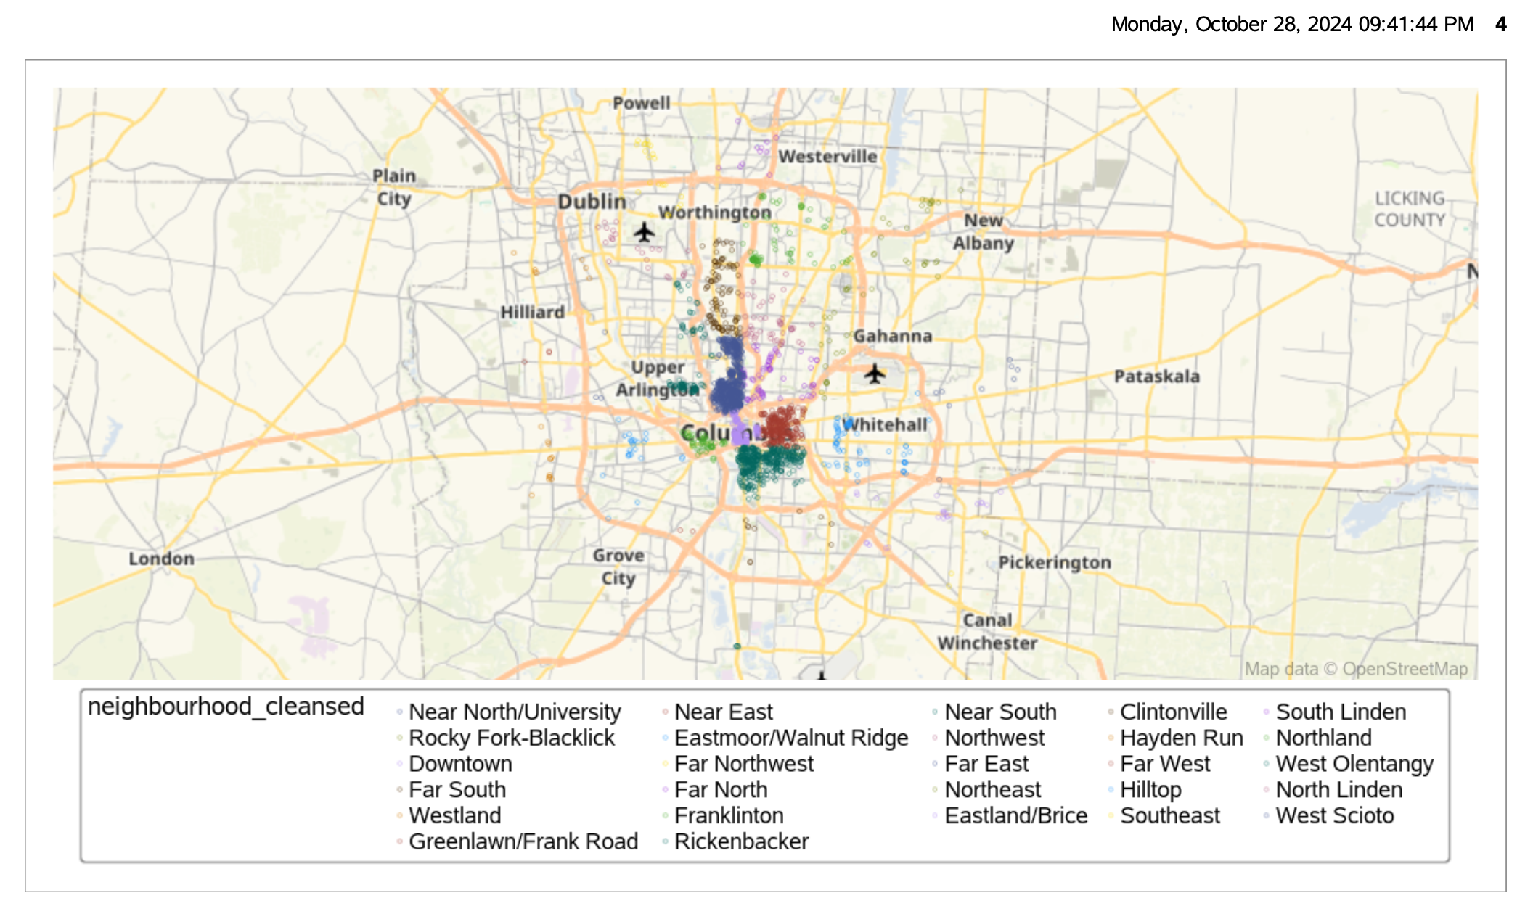

**Data Overview**

I executed the PROC CONTENTS procedure to familiarize myself with the structure of the imported data in SAS. This preliminary overview revealed that the dataset contains a total of 2,432 observations and 75 variables. Out of these variables, several are numeric while the rest are character types, providing a diverse set of data points for analysis. This structural insight sets the stage for a thorough examination of the factors influencing Airbnb prices in Columbus, Ohio.

**Studying the Dependent Variable: Price**

In analyzing the Airbnb listings, the 'Price' variable has been thoroughly evaluated using the UNIVARIATE procedure in SAS, revealing detailed statistics:

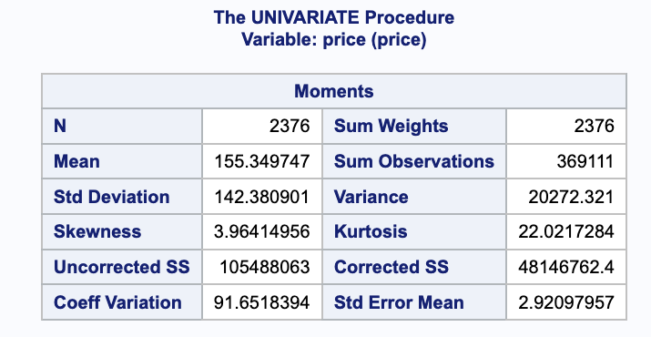

- Count (N): The total number of price observations is 2,376.

- Mean Price: The average price of listings is $155.35, setting a standard for the general cost of Airbnb rentals in the area.

- Standard Deviation: At $142.38, the standard deviation is high, indicating a wide variation in listing prices, which suggests the presence of both modestly priced and high-end listings.

- Variance: The price variance is substantial at 20,272.321, supporting the wide range in data spread.

- Skewness: With a skewness of 3.96, the distribution is right-skewed, highlighting that most listings are priced below the average, with a few expensive outliers.

- Kurtosis: The kurtosis of 22.02 shows a leptokurtic distribution, indicating a peaked data set with prices clustering around the mean and some extreme values far from it.

- Sum Weights: Matching the number of observations, sum weights are also 2,376.

- Sum Observations: The total sum of all price values in the dataset is 369,111.

- Uncorrected Sum of Squares (SS): The uncorrected sum of squares is 105,488,063, representing the sum of squared deviations from zero.

- Corrected Sum of Squares (SS): The corrected sum of squares, which represents the sum of squared deviations from the mean, is 48,146,762.4.

- Coefficient of Variation: At 91.65%, this measure shows relative variability, indicating the level of risk or volatility in price relative to the mean.

- Standard Error of Mean: The standard error of the mean price is 2.93, giving an idea of the precision of the mean price estimate.

These metrics are instrumental for deeper insights into the pricing dynamics of Airbnb listings in Columbus, providing a foundation for predictive modeling and market analysis.

**Quantile Analysis of Price Variable for 1% and 99%**

In the distribution of Airbnb prices in Columbus, Ohio, focusing on the extremes captured at the 1% and 99% quantiles provides valuable insights into the range of pricing:

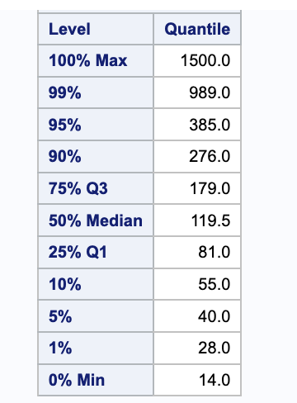

- 1st Percentile (1%): At this low percentile, the price is $28.00. This indicates that only 1% of Airbnb listings are priced below this amount, highlighting the baseline price level for the most affordable listings in the market.

- 99th Percentile (99%): At the high end, the price rises to $989.00. This level means that 99% of all listings are priced below this amount, and only 1% of listings have prices above this threshold, showcasing the upper extreme of the market.  
  
The data shows that in Columbus, Ohio, "Near North/University" and "Downtown" have the highest-priced listings due to their desirable locations and proximity to major attractions. In contrast, "Eastmoor/Walnut Ridge" and "Northland" feature the most economical listings, which are great for those seeking budget-friendly accommodations.

This focused quantile analysis helps in understanding the outliers and the typical pricing extremes within the Airbnb market in Columbus, which can be critical for strategic pricing and market analysis.

**Extreme Observations:** Recognizing extreme observations aids in comprehending the data's range and any outliers.

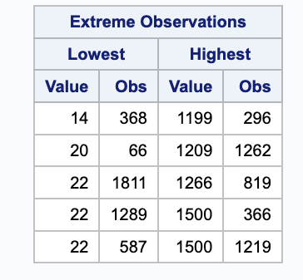

Listings with prices as low as $14 and as high as $1199 are notable signs of extreme observations.

**Goodness-of-Fit Tests for Normal Distribution of Price Variable**

The goodness-of-fit tests are utilized to determine if the 'Price' variable aligns with a normal distribution. The results from these tests are as follows:

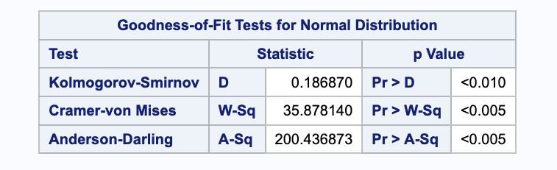

- Kolmogorov-Smirnov Test: The statistic is 0.186870 with a p-value less than 0.010, indicating a significant deviation from normality.

- Cramer-von Mises Test: The statistic is 35.878140 with a p-value less than 0.005, further confirming the departure from a normal distribution.

- Anderson-Darling Test: The statistic is 200.436873 with a p-value less than 0.005, strongly suggesting a significant deviation from normality.

These results collectively demonstrate that the distribution of Airbnb prices in Columbus, Ohio, significantly deviates from a normal distribution, which is supported by the calculated statistics and very low p-values in all tests.

**Analysis of Price Distribution**

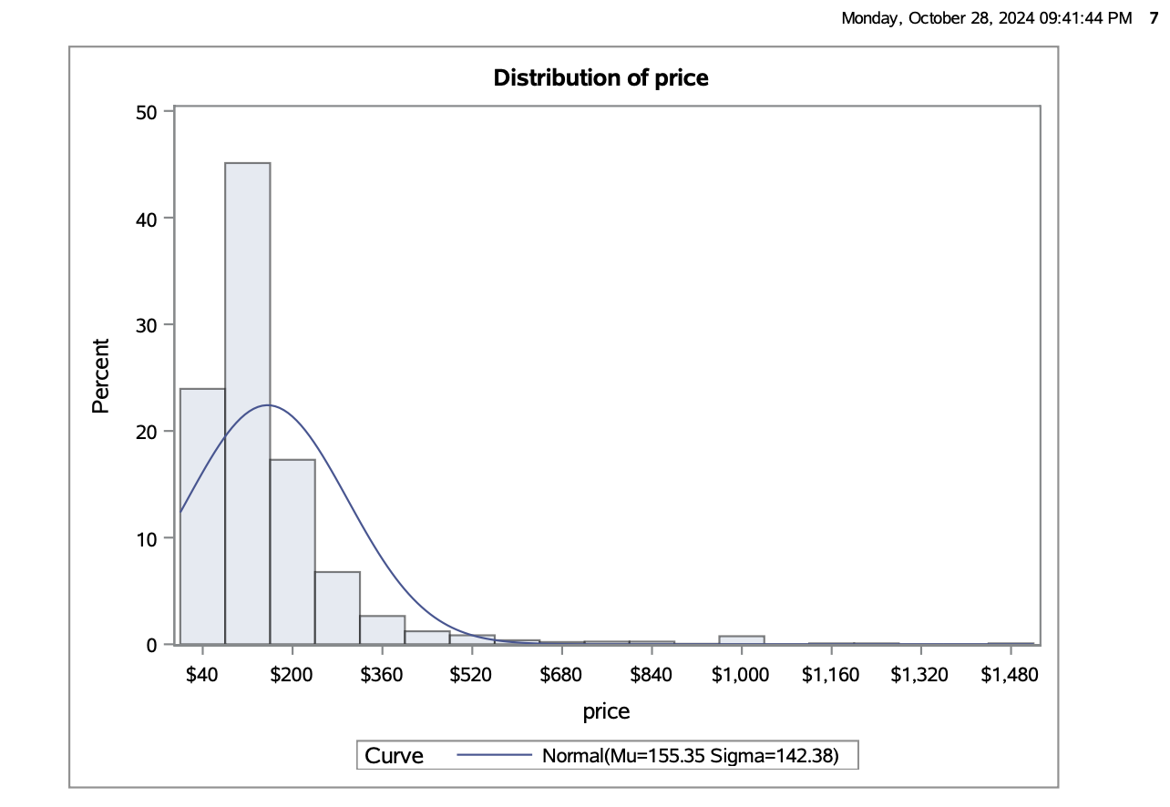

The price distribution of Airbnb listings in Columbus, Ohio, is distinctly right-skewed, as illustrated by the histogram and its comparison to a normal distribution curve.

The histogram reveals a concentration of listings at lower price points with a gradual decrease as prices rise, diverging significantly from the expected bell curve of a normal distribution.

This deviation is substantiated by the goodness of-fit tests Kolmogorov-Smirnov, Cramer-von Mises, and Anderson-Darling all of which confirm a significant departure from normality with very low p-values.

This analysis indicates that most Airbnb listings are affordable, with a few outliers at higher prices.

Here are the insights from the summary statistics of the distribution of the log-transformed 'Price':

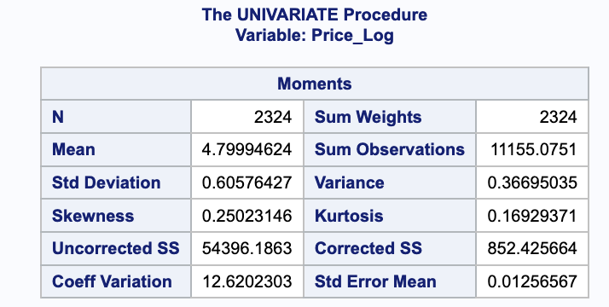

- Mean: The average log-transformed price is approximately 4.7999.

- Standard Deviation: The spread of log-transformed prices is 0.6058.

- Skewness: The skewness of 0.2502 indicates a slight rightward skew, suggesting that the log-transformed prices are more symmetrically distributed than the original prices.

- Kurtosis: The kurtosis of 0.1693 implies a relatively normal distribution, with fewer extreme values compared to a perfectly normal distribution.

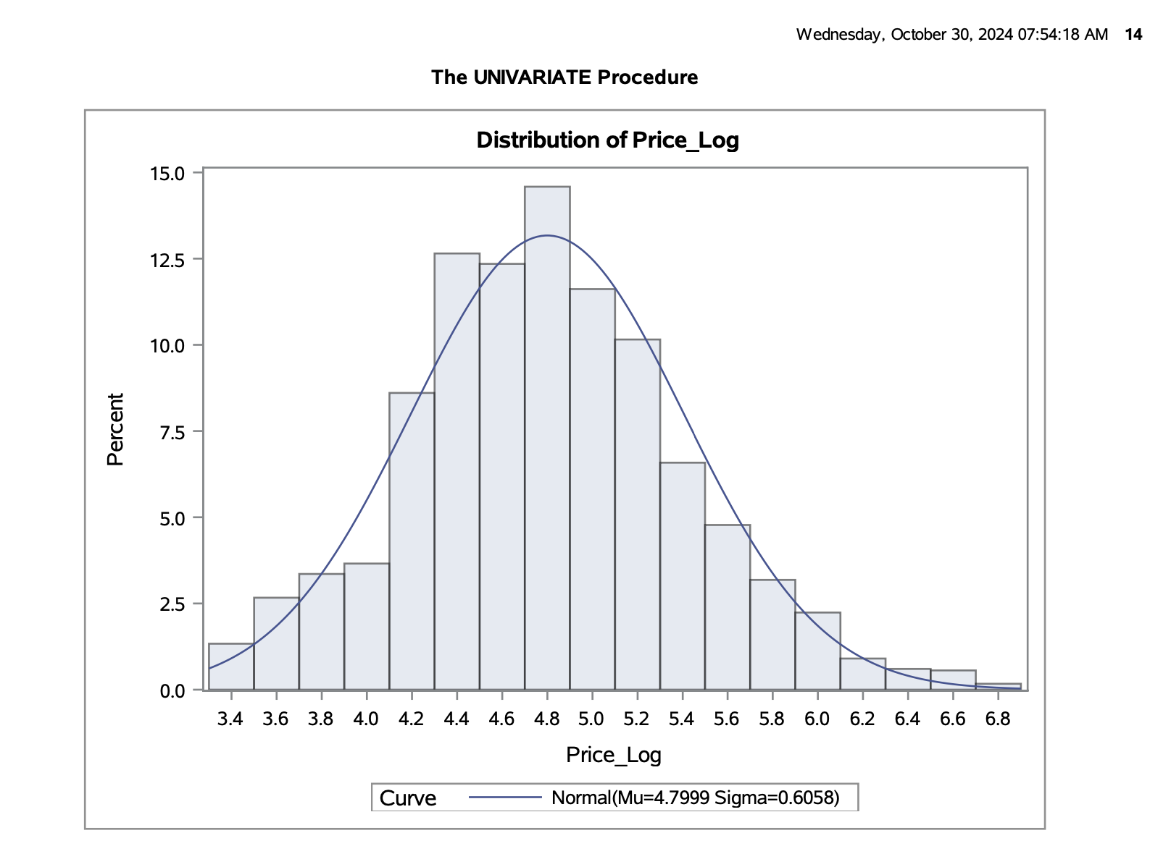

The histogram in the image illustrates the distribution of log-transformed prices, showcasing a close approximation to a normal distribution.

**Analysis of Log-Transformed Price Distribution**

The histogram presented reflects the distribution of the log-transformed prices. The transformation has been applied to address skewness and normalize the data, facilitating more effective statistical analysis, particularly methods that assume normality.

- Central Tendency and Spread: The mean of the log-transformed prices is 4.7999, indicating the central point of the distribution. The standard deviation, 0.6058, measures the dispersion of the data points from the mean, suggesting a moderate spread across the values.

- Normality: The overlaid normal curve provides a visual confirmation that the log-transformed prices closely follow a normal distribution. This is essential for various statistical tests and regression models that assume normally distributed data.

- Skewness and Kurtosis: The skewness value of 0.2502 implies a slight rightward skew, though the distribution remains relatively symmetric, as seen in the bulk of data clustering near the mean. The kurtosis of 0.1693 is indicative of a distribution with fewer extreme values or outliers than a perfect normal distribution, which supports the effectiveness of the log transformation in normalizing the data.

- Implications for Analysis: With the data approximating normal distribution, parametric tests that require normality can be considered more reliable and valid when applied to this dataset. The transformation has mitigated the impact of outliers and has structured the data into a form that is more amenable to classical statistical methods.

This graphical representation confirms that the log transformation was successful in stabilizing the variance and normalizing the distribution of prices, setting a robust foundation for further inferential statistical analysis.

The detailed summary of missing value handling and exclusions in Columbus, Ohio, can be found in the “Summary – Numeric Variables” section of the appendices in the analysis results document. This section provides a clear breakdown of the excluded variables and the approach taken to handle missing values across several key variables:

**Missing Values Strategy:**

- Variables such as host_response_rateand host_acceptance_rate had missing values replaced with their means.

- Bathrooms missing entries were set to "0," assuming no bathroom facility exists.

- Missing data in bedrooms and, beds were replaced with the means, assuming a basic means provision in listings.

- Review score variables with missing data were also replaced with the mean to avoid skewing the results.

These strategies ensure data integrity, reduce bias, and improve the quality of subsequent analyses. The full PROC MEANS output in the appendix confirms the summary statistics and handling criteria.

The results from PROC MEANS for the variables accommodates, bathrooms, bedrooms, and beds, as well as their percentiles including the 99th percentile, can be found on page 17 of your PDF file. Here, the statistical details such as minimum, maximum, mean, median, standard deviation, and specific percentiles (1st, 10th, 25th, 50th, 75th, 90th, 95th, and 99th) for these variables are provided.

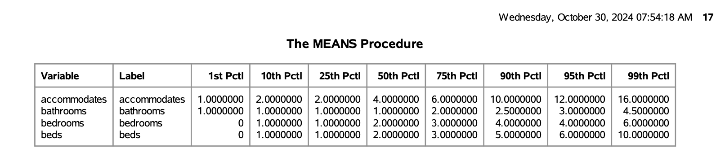

**Setting Thresholds**

setting thresholds at the 99th percentile for accommodates, bathrooms, bedrooms, and beds is appropriate if these variables are prone to outliers. It ensures that most of the data range remains unchanged, focusing on outlier management for a more robust analysis.

**Checking Levels**

PROC FREQ procedure is used to generate a summary of levels for each variable.

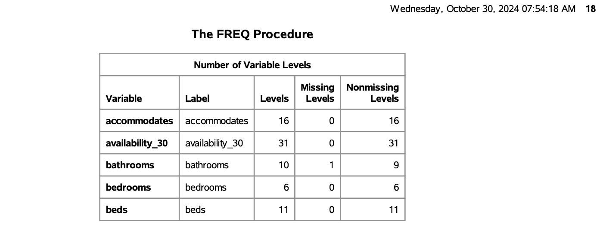

**Categorization Criteria Based on Frequency Distribution**

To facilitate more meaningful analysis, frequency distributions from the PROC FREQ results were used to categorize the variables accommodates, bathrooms, bedrooms, and beds. The categorization criteria are as follows:

1. Accommodates:

- Categories are based on common group sizes observed in the frequency distribution.

- Single Occupancy: 1 person

- Small Groups: 2-4 people

- Medium Groups: 5-8 people

- Large Groups: 9+ people

- This breakdown supports grouping by different accommodation sizes to better understand capacity trends.

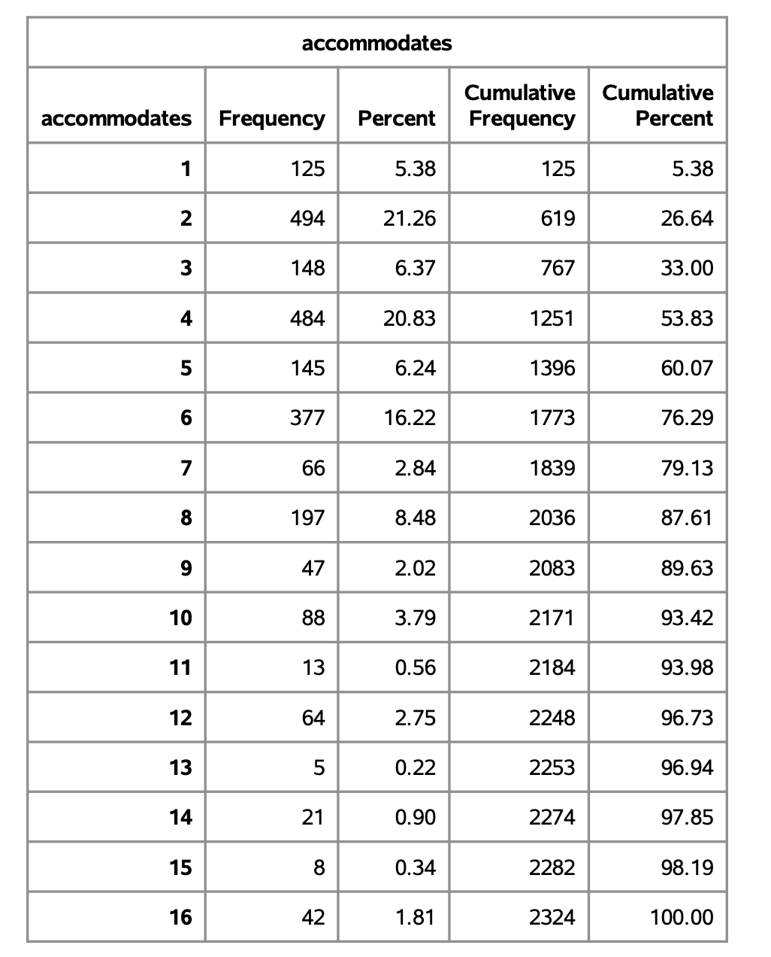

Here are concise notes for the ‘availability_30’ variable:

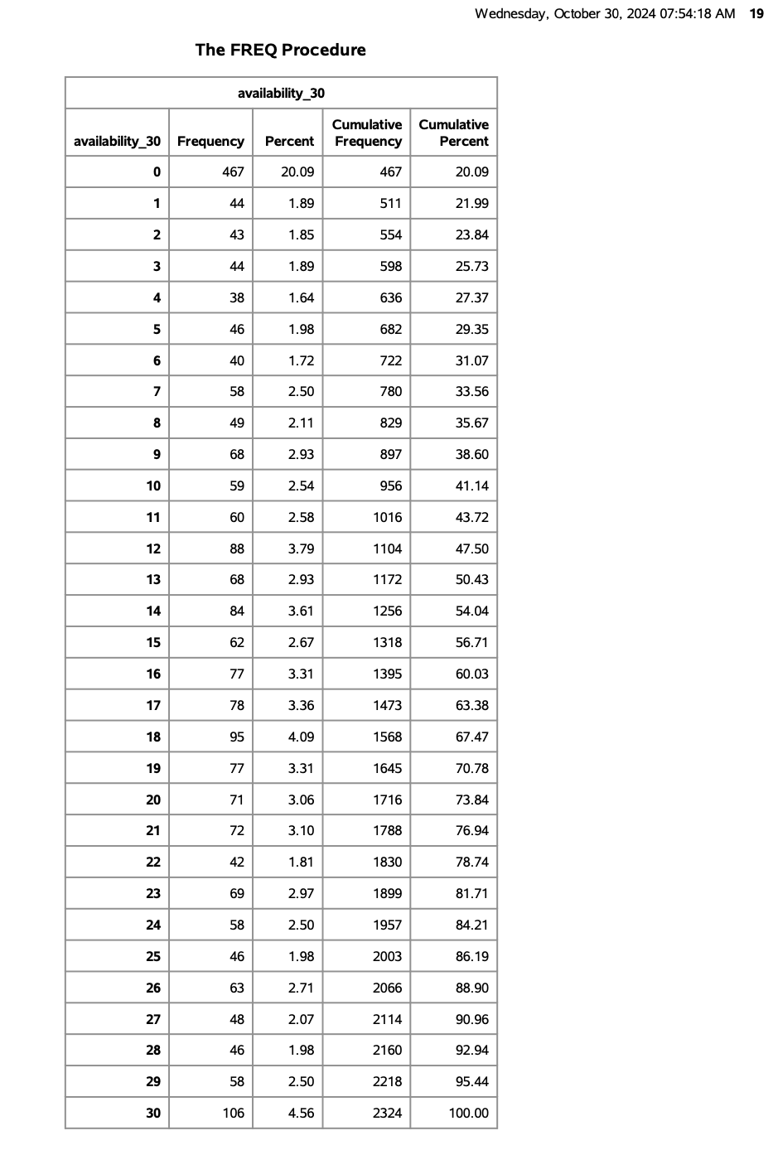

- 0 Days (Fully Booked): 20.09% of listings.

- Low Availability (1-10 days): ~22%.

- Moderate Availability (11-20 days): ~24%.

- High Availability (21-30 days): ~31%.

- Key Trend: 50% of listings are booked up to 13 days; 75% booked up to 20 days.

**2. Bathrooms:**

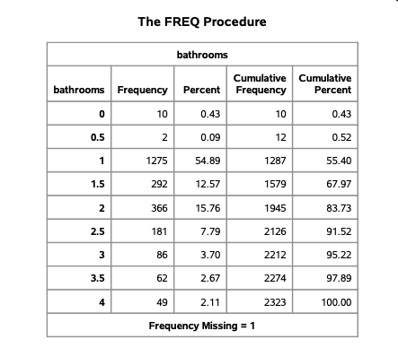

- Categories reflect common listings, highlighting properties with shared or private bathrooms.

- Minimal Bathrooms: 0-1 (often shared or small private spaces)

- Standard Bathrooms: 1.5-2

- High-Capacity Bathrooms: 3+

- These categories reflect user preferences for listings based on bathroom availability.

**3. Bedrooms:**

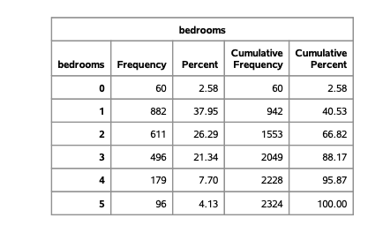

- Studios: 0-1 bedrooms

- Small Properties: 2 bedrooms

- Medium Properties: 3 bedrooms

- Large Properties: 4+ bedrooms

- Bedroom categorization is useful in analyzing listings by living space size.

**4. Beds:**

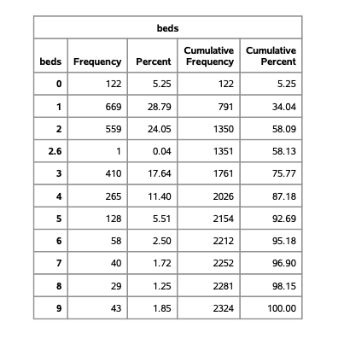

- Categories based on the frequency of bed counts per listing:

- Single Bed: 1 bed

- Twin Beds: 2 beds

- Multiple Beds: 3-4 beds

- High-Capacity Beds: 5+ beds

- This breakdown allows analysis of sleeping capacity and preference.

Categorizing these variables, standardize the analysis and make it easier to identify trends, providing a clearer understanding of the typical accommodation types available.

This table summarizes the parameter estimates, standard errors, t-values, p-values, and variance inflation factors (VIFs) for various variables used in the regression model. Here’s an explanation of each section:

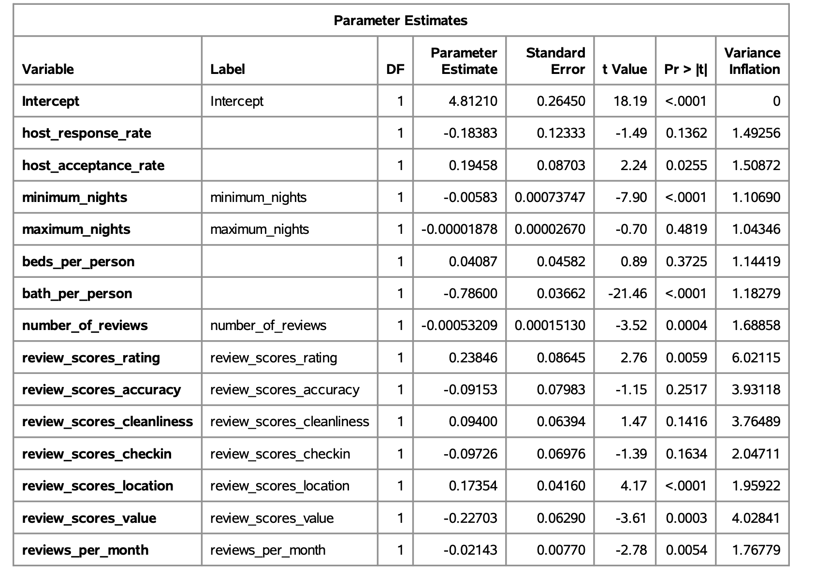

1. Parameter Estimates: This column provides the estimated coefficients for each variable, indicating their impact on the dependent variable. Positive values suggest a positive relationship, while negative values indicate a negative relationship. For instance, bath_per_person has a coefficient of -0.786, showing a negative association.

2. Standard Error: This column shows the standard error of each coefficient estimate, reflecting the variability of the estimates. Smaller values indicate more precise estimates. For example, bath_per_person has a low standard error of 0.03662, indicating precision.

3. t Value: This statistic tests whether the coefficient is significantly different from zero. High absolute t-values indicate stronger evidence against the null hypothesis. For instance, bath_per_person has a t-value of -21.46, showing it is highly significant.

4. Pr > |t| (p-value): This column shows the significance of each variable. Lower p-values (usually < 0.05) indicate statistical significance. Variables such as host_acceptance_rate, minimum_nights, and review_scores_location have significant p-values, while beds_per_person, review_scores_accuracy, and review_scores_checkin are not statistically significant (p > 0.05).

5. Variance Inflation Factor (VIF): This measures multicollinearity among variables. Values above 5 suggest high multicollinearity, which can inflate the standard errors of the coefficients. In this table, most VIFs are below 5, indicating low multicollinearity. However, review_scores_rating and review_scores_value have higher VIFs (6.02115 and 4.02841, respectively), but they are still below the critical threshold of 10.

- Significant Variables: host_acceptance_rate, minimum_nights, bath_per_person, number_of_reviews, and review_scores_rating are statistically significant predictors of the dependent variable.

- Non-Significant Variables: beds_per_person, review_scores_accuracy, and review_scores_checkin have higher p-values, suggesting they are not significant predictors.

- Multicollinearity: There is low multicollinearity among the variables, making the estimates reliable.

This table helps identify which variables are most influential in the model and confirms that multicollinearity is not a major concern.

**Polynomial terms:**

In examining the potential inclusion of polynomial terms, it was found that higher-degree polynomials significantly elevated the Variance Inflation Factors (VIFs), indicating increased multicollinearity. To maintain model stability and prevent inflated VIFs, no polynomial terms were included in the final model.

Histogram displays the distribution of the log-transformed variable min_nights_tf, which is a transformed version of minimum_nights using a log transformation.

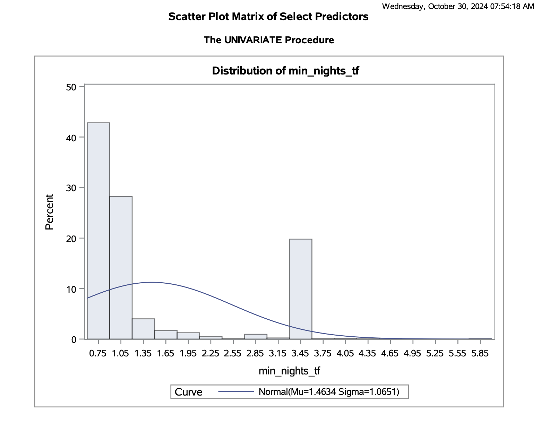

- Distribution Shape: The log transformation has partially addressed the skewness of the original minimum_nights variable, but a rightward skew remains evident. This indicates that while the transformation has helped, many listings still have low minimum nights required, with fewer listings requiring higher minimum nights.

- Normal Curve Fit: The overlaid normal curve (with mean 1.4634 and standard deviation 1.0651) shows that the distribution deviates from perfect normality, with many values clustered at the lower end.

This transformed distribution suggests that while normalization has improved, min_nights_tf still shows a heavy concentration at lower values, indicating the variable's tendency toward short minimum night requirements across listings.

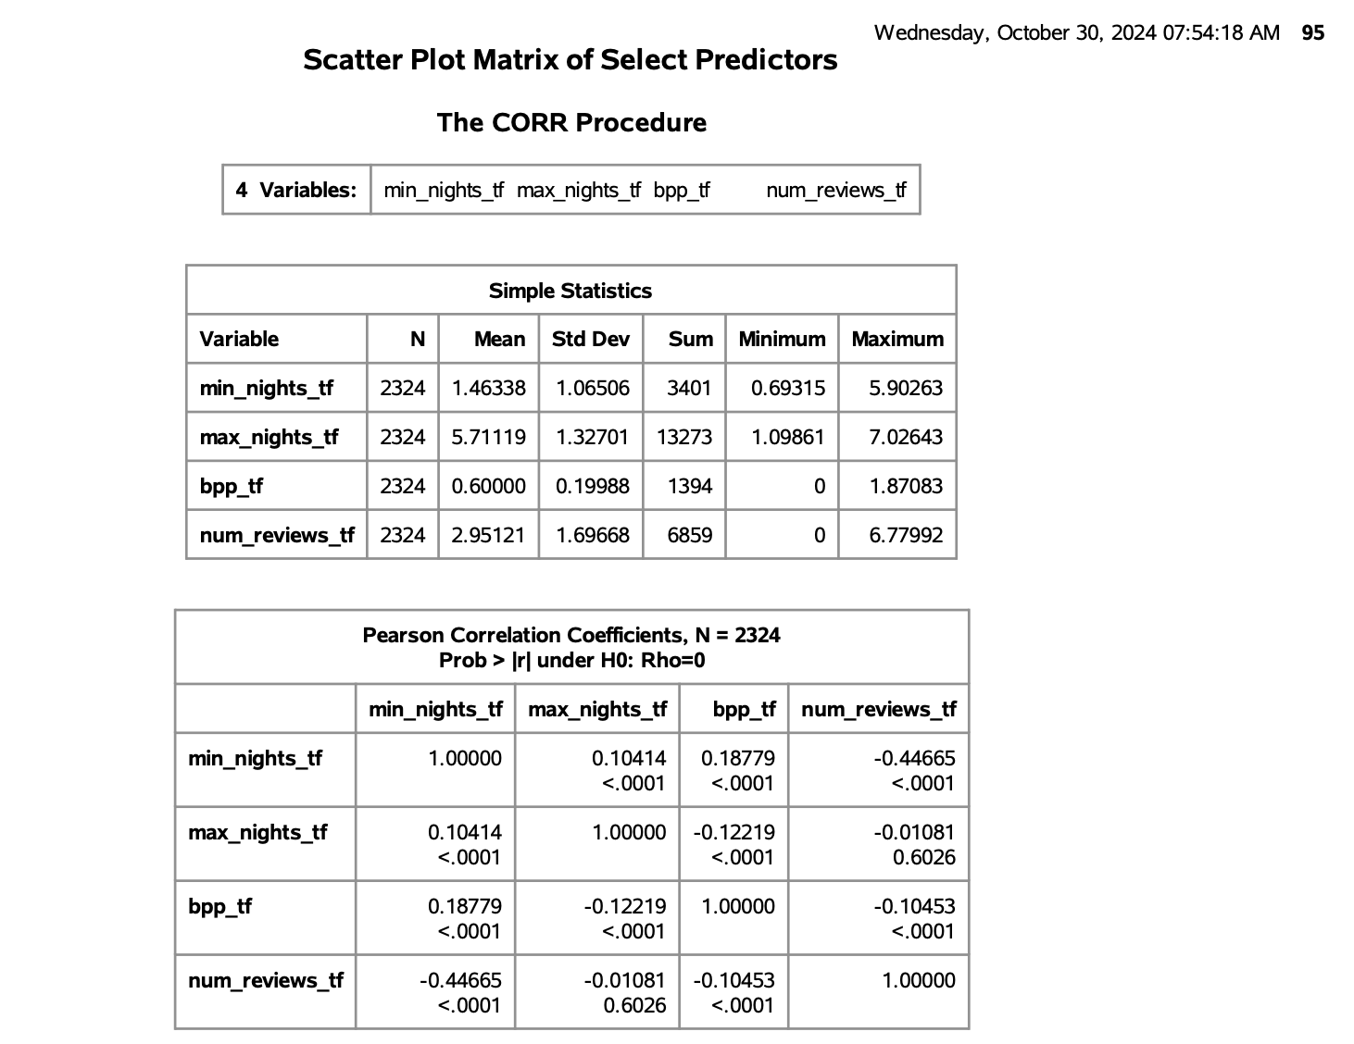

This table summarizes simple statistics and correlations for the transformed variables min_nights_tf, max_nights_tf, bpp_tf (bath per person), and num_reviews_tf (log-transformed number of reviews):

- min_nights_tf: Transformed minimum nights requirement, with a low mean (1.46), indicating most listings have short minimum stays. Negatively correlated with num_reviews_tf, suggesting shorter stays attract more reviews.

- max_nights_tf: Transformed maximum nights allowed, with a higher mean (5.71), showing flexibility in stay duration. Minimal correlation with other variables, indicating independence.

- bpp_tf: Baths per person, transformed for normalization. A mean of 0.6 reflects a moderate bathroom-to-guest ratio. Slight positive link with min_nights_tf.

- num_reviews_tf: Transformed review count, with a mean of 2.95. Higher review counts are associated with shorter minimum stay requirements.

A scatterplot matrix has been generated for the above numeric variables in the model.

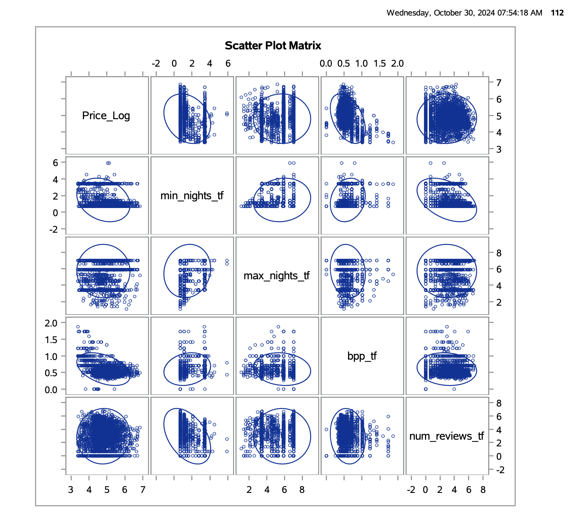

This scatter plot matrix displays relationships between the transformed variables (min_nights_tf, max_nights_tf, bpp_tf, and num_reviews_tf) and Price_Log. Each pairwise plot reveals the degree and nature of correlation. Ellipses suggest weak to moderate correlations, with some visible clustering and patterns. Notably, num_reviews_tf shows a dispersed relationship with Price_Log, indicating possible influence, while min_nights_tf and max_nights_tf display limited association, suggesting minimal direct impact on Price_Log. This visual aids in understanding the dependencies and potential predictor strength among variables.

**Character Variable Inquiry**

This table from the PROC FREQ procedure displays the number of unique levels for three-character variables used in the analysis:

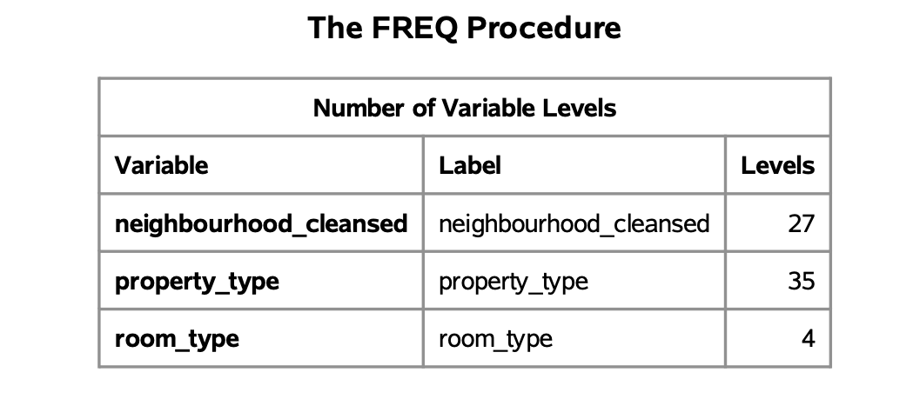

- neighbourhood_cleansed: 27 distinct neighborhood categories, reflecting the geographical diversity in listings.

- property_type: 35 unique property types, highlighting a wide range of accommodation types.

- room_type: 4 main room types, offering various levels of privacy and space.

These counts provide insight into the dataset's categorical diversity, essential for segmenting listings based on neighborhood demand, property type, and room type preferences.

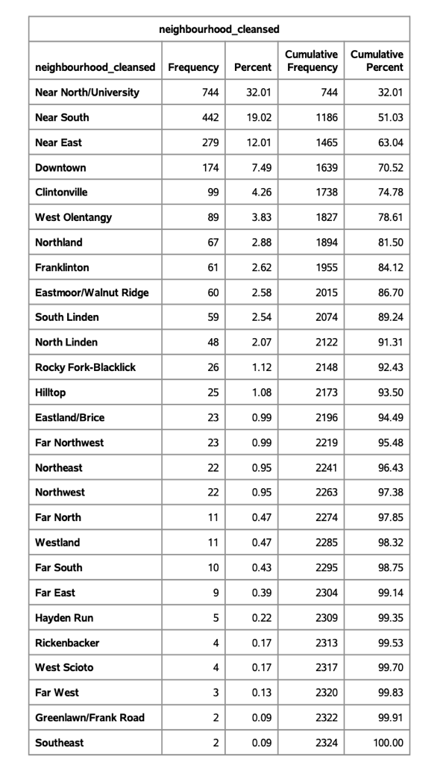

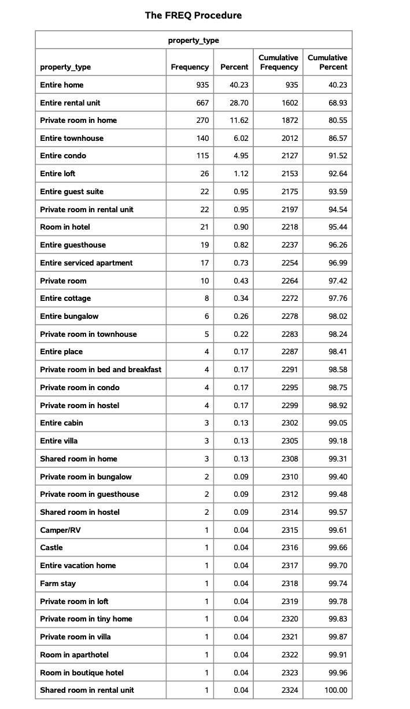  
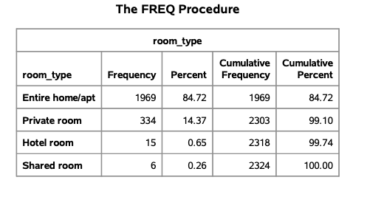

- neighbourhood_cleansed: The top neighborhoods, like "Near North/University" (32.01%) and "Near South" (19.02%), make up over 50% of listings, indicating higher demand in these areas. The remaining neighborhoods have progressively fewer listings, contributing to a cumulative 100%.

- property_type: "Entire home" (40.23%) and "Entire rental unit" (28.7%) dominate the listings, covering about 69% collectively. The remaining 31% includes diverse property types, each contributing a small percentage.

- room_type: "Entire home/apt" is the most common room type, accounting for 84.72% of listings. "Private room" follows at 14.37%, while "Hotel room" and "Shared room" are rare, collectively under 1%.

**Data Partitioning**

To ensure robust model evaluation, the dataset was split into training and test sets using the PROC SURVEYSELECT procedure. An 80/20 split was applied, where:

- TRAIN Dataset (80%): Used for model training to uncover patterns and relationships within the data.

- TEST Dataset (20%): Held back for model testing, allowing assessment of model performance on unseen data, providing insight into its generalization capability.

**Predictive Modelling:**

The model includes both numeric and categorical variables to capture diverse listing attributes.

- Numeric Variables:

- min_nights_tf, max_nights_tf: Transformed minimum and maximum night requirements.

- bpp_tf: Bathrooms per person.

- num_reviews_tf: Log-transformed count of reviews.

- Categorical Variables:

- Booking and Availability: instant_bookable (true/false), avail_cat (Booked, High, Low, Medium).

- Property Features: accom_cat (Large to Very_Small), bath_cat (Luxury, Extra, Normal, Nil), bedrooms_cat, and beds_cat (Single, Double, Extra).

- Host Metrics: resp_cat (Bad to Perfect), acc_cat (Absolute to Zero), rating_cat (Bad to Perfect).

- Location and Type: hood_cat (Low-Demand), property_cat (Primary, Secondary, Others), and room_cat (Home, Room).

**Linear Regression:**

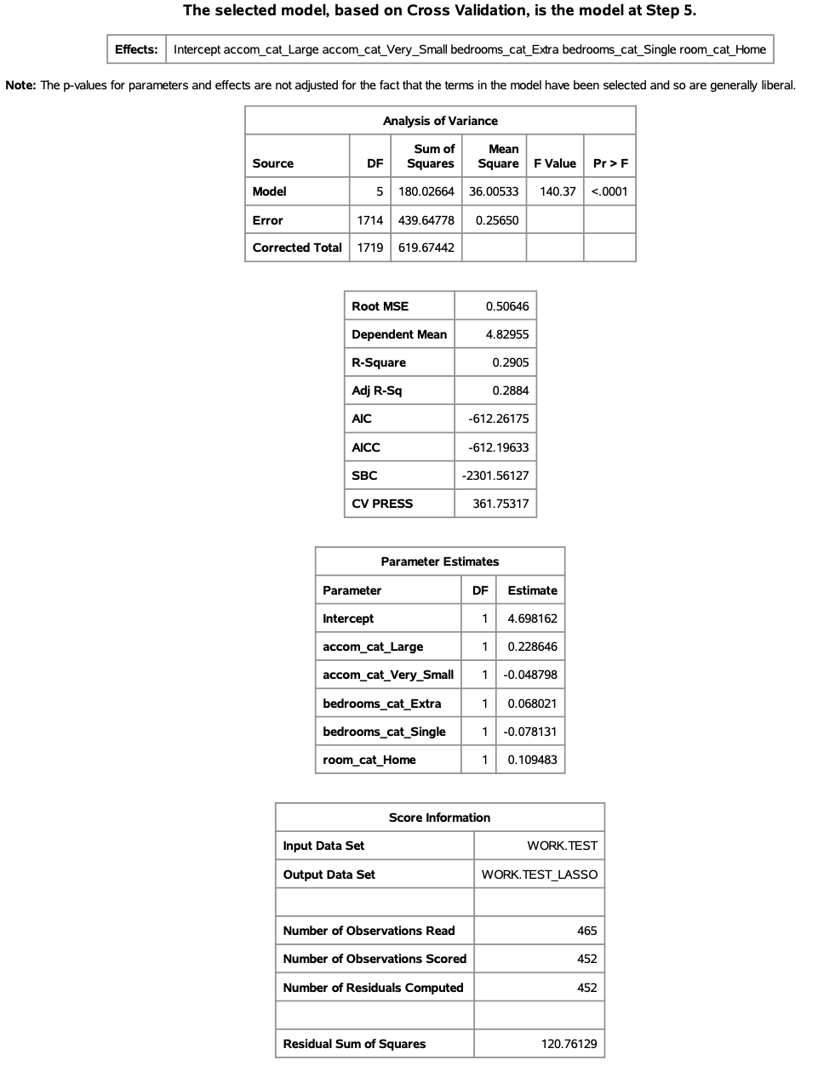

1. Model Selection and Performance:

- A LASSO regression model was selected at Step 5, based on Cross-Validation (CV), which helps ensure generalizability.

- The final model includes significant predictors such as accom_cat_Large, accom_cat_Very_Small, bedrooms_cat_Extra, bedrooms_cat_Single, and room_cat_Home.

2. ANOVA and Model Fit:

- The ANOVA table indicates the model is statistically significant, with an F-value of 140.37 and a p-value < 0.0001.

- R-Square is 0.2905, suggesting the model explains approximately 29% of the variance in Price_Log.

- Root MSE of 0.50646 provides a measure of error in the model's predictions.

3. Parameter Estimates:

- The intercept is estimated at 4.698162.

- Positive relationships with Price_Log are observed for categories like accom_cat_Large (0.228646) and room_cat_Home (0.109483).

- Negative relationships are observed for categories like accom_cat_Very_Small (-0.048798) and bedrooms_cat_Single (-0.078131).

4. Model Evaluation:

- The CV PRESS (361.75317) indicates the cross-validation prediction error, supporting model accuracy for unseen data.

- AIC (-612.26), AICC (-612.19), and SBC (-2301.56) suggest model fit, and complexity are balanced.

5. Score Information:

- The model was scored on the test dataset, with residuals computed for 452 observations out of 465, allowing for evaluation on new data.

These metrics highlight model strength, predictor impact, and fit quality, providing a robust predictive foundation for Price_Log.

**Verifying Linear Regression**

This plot assesses the linearity between observed and predicted values of Price_Log. The scatter of data points around the regression line indicates the relationship captured by the model. The slight upward trend of the line suggests a positive linear association, though some dispersion around the line indicates variability.

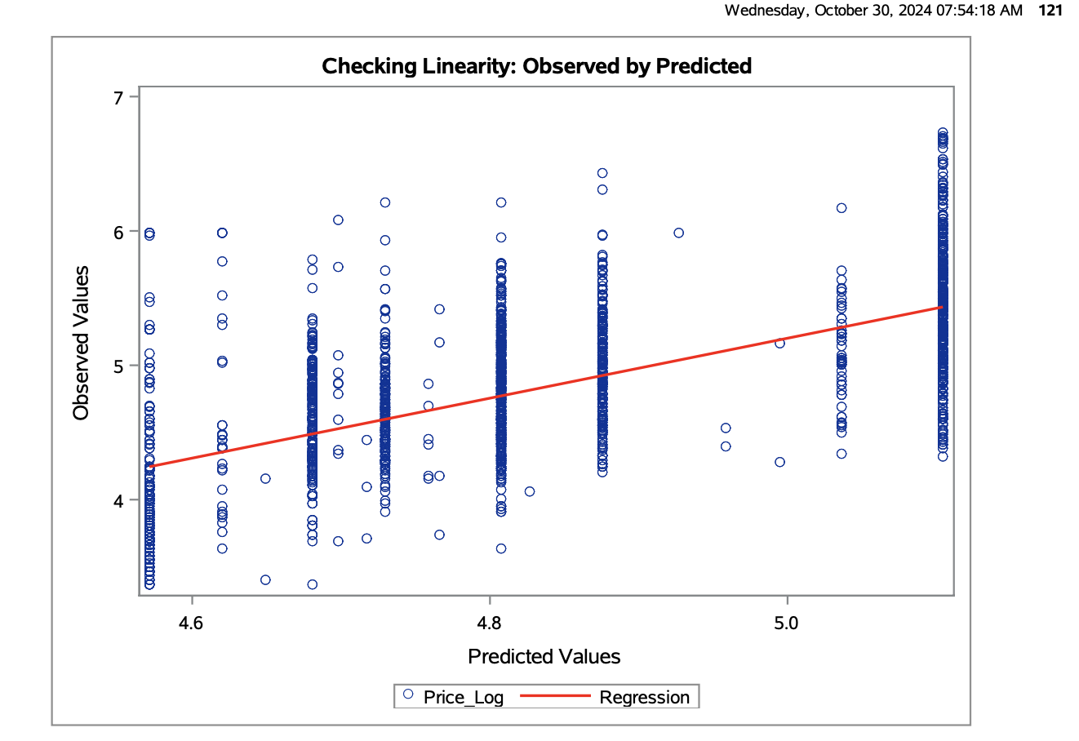

Overall, while the model captures the general trend, the spread of points implies that further refinement or additional predictors might improve the accuracy of predictions across the full range of observed values. This visualization confirms that the model’s linear assumptions are met reasonably, supporting its application on the data.

**Homoscedasticity**

This plot checks for homoscedasticity by examining residuals against predicted values of Price_Log. Ideally, residuals should be randomly dispersed around zero without any pattern.

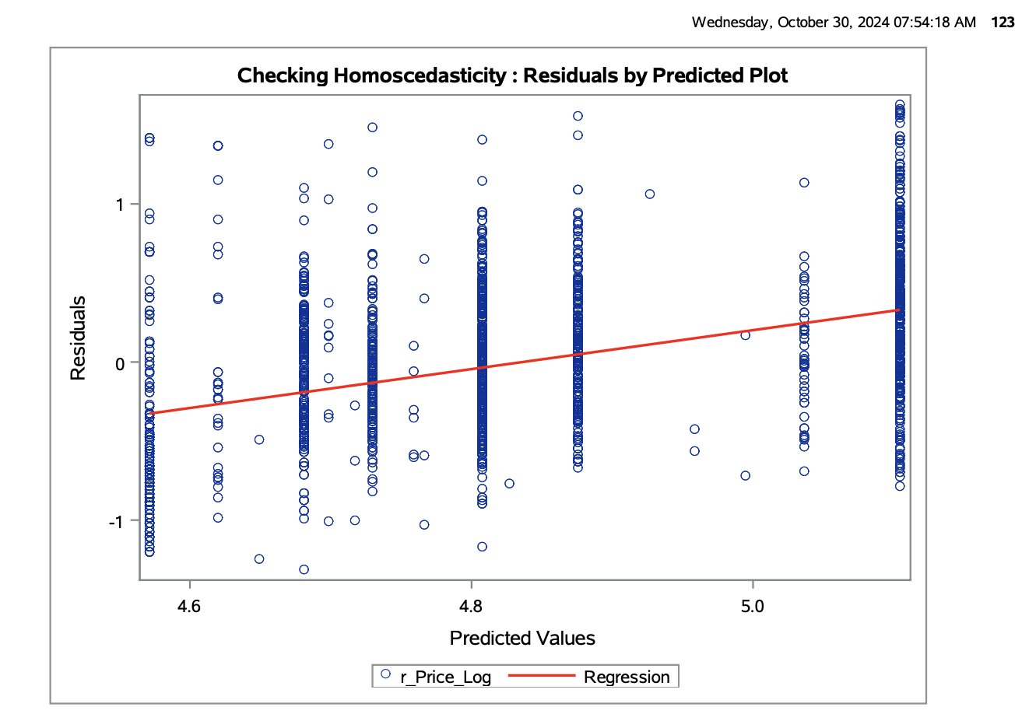

Observations:

- Variance Pattern: The residuals display a relatively consistent spread around the regression line, though a slight upward trend is visible.

- Implication: This suggests that while the model generally maintains homoscedasticity, there is a minor variance pattern that may indicate a slight model misspecification.

Overall, the plot shows acceptable homoscedasticity, with only minimal deviation, supporting the model's assumption that residuals have constant variance.

**Independence**

This R-Student by Predicted Plot is used to verify the assumption of residual independence:

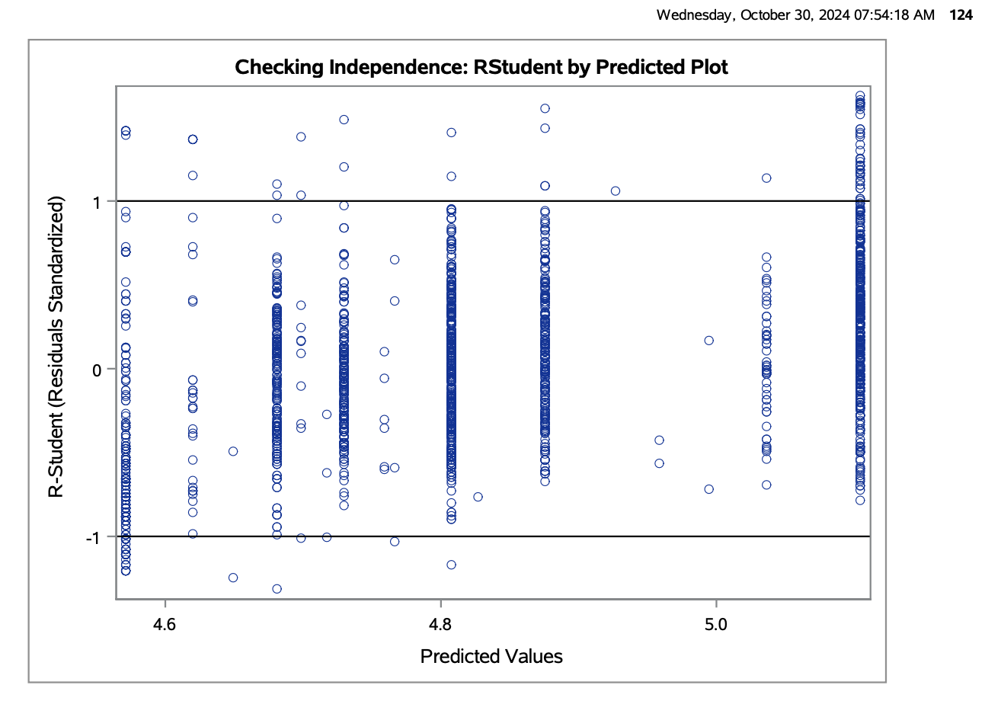

- Random Spread: The plot displays a random dispersion of residuals around zero, with no apparent patterns, supporting the independence of residuals.

- Consistency: The spread remains relatively constant across the predicted values, suggesting no systematic error.

- Outliers: Although some outliers are present, they are few and scattered, minimizing their impact on the model.

In summary, the plot confirms the independence assumption, as residuals are evenly dispersed with no discernible structure across predicted values.

**Normality**

From this histogram of residuals, we can infer that the normality assumption is generally satisfied. The plot shows a roughly symmetric, bell-shaped distribution, which aligns closely with the normal curve, though there is a slight peak that might suggest a minor deviation from perfect normality.

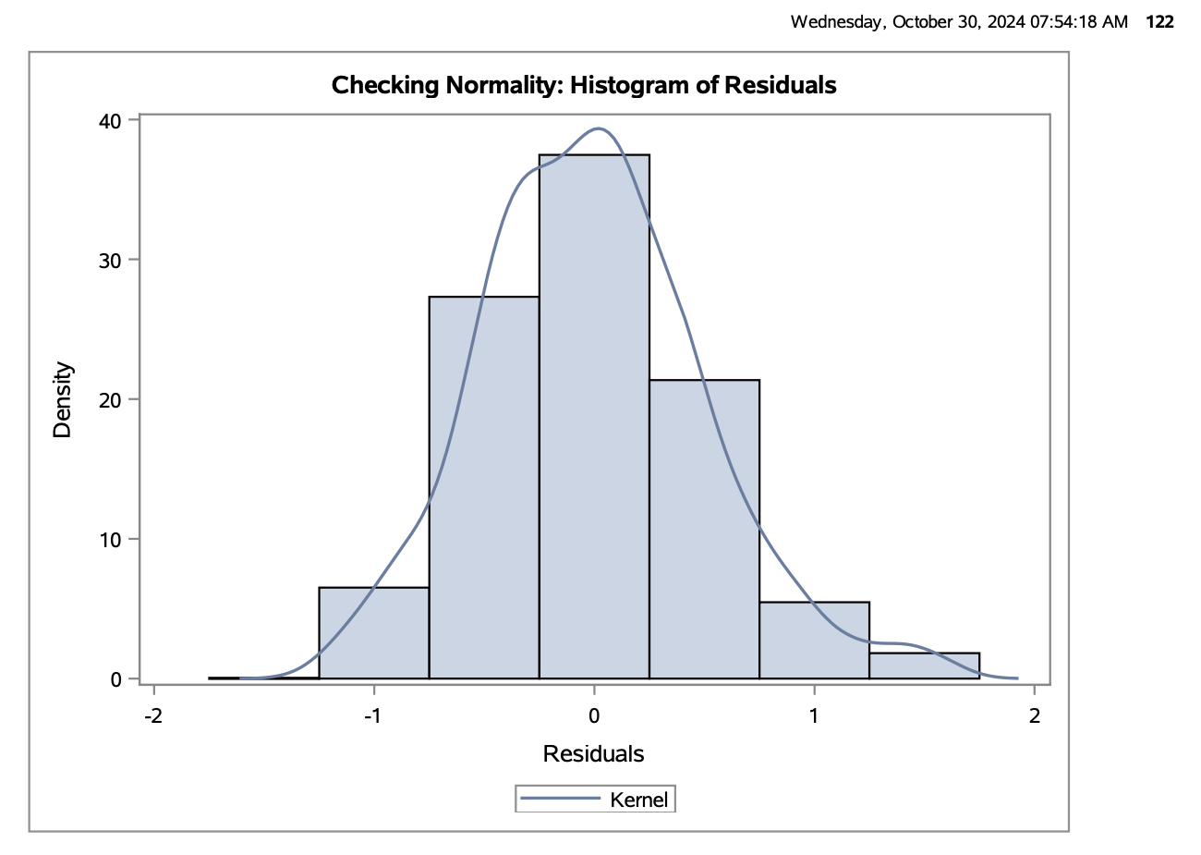

This minor deviation does not significantly impact the model’s reliability because:

- Robustness: Linear regression is resilient to slight violations of normality, especially in large samples.

- Assumptions Met: Other assumptions (linearity, homoscedasticity, and independence) are also satisfied, further supporting the model's dependability.

Thus, the model remains robust, providing reliable estimates and inferences despite this minor irregularity in residual distribution.

**Evaluating the model performance**

This table provides an overview of the linear regression model results for Price_Log:

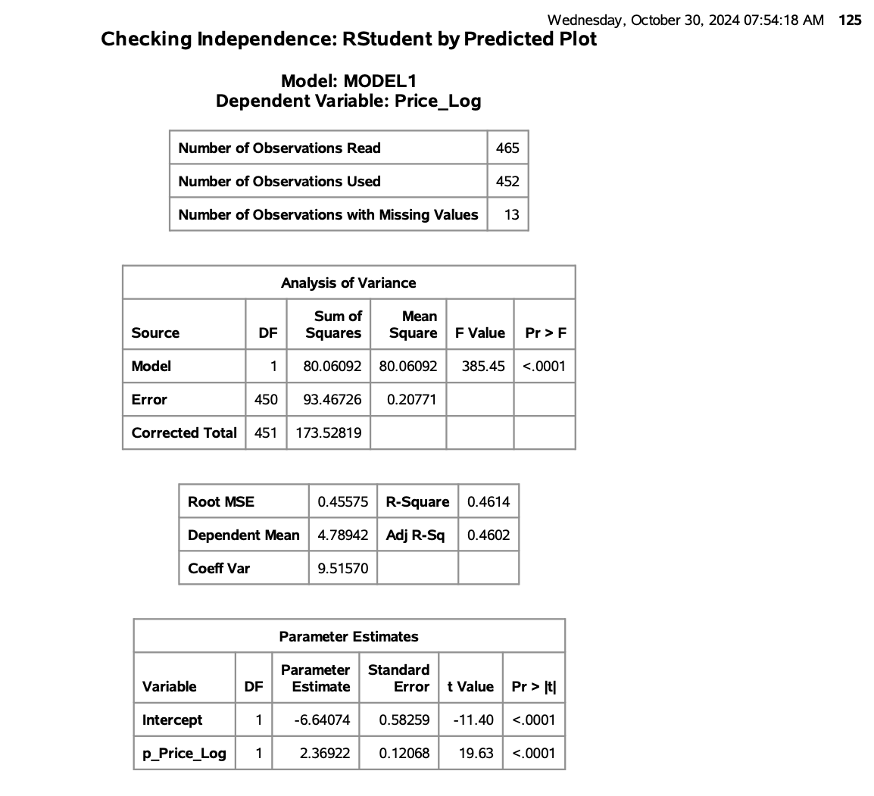

1. Model Summary:

- Observations: 452 used, with 13 missing values.

- R-Square: 0.4614, indicating the model explains 46.14% of the variance in Price_Log.

- Adjusted R-Square: 0.4602, which adjusts for the number of predictors.

2. ANOVA:

- F Value: 385.45, with a p-value < 0.0001, confirming the model is statistically significant.

3. Parameter Estimates:

- Intercept: -6.64074, statistically significant with a t-value of -11.40.

- p_Price_Log (predictor): Estimate of 2.36922, highly significant with a t-value of 19.63.

4. Error Metrics:

- Root MSE: 0.45575, indicating the average deviation of predictions from actual values.

- Coefficient of Variation: 9.51570, reflecting model precision relative to the mean of Price_Log.

Overall, these metrics suggest a well-fitting model with significant predictors, explaining a substantial portion of Price_Log variability.

**Interpreting the results**

The LASSO selection process identified key predictors in six steps, progressively refining the model to minimize prediction error:

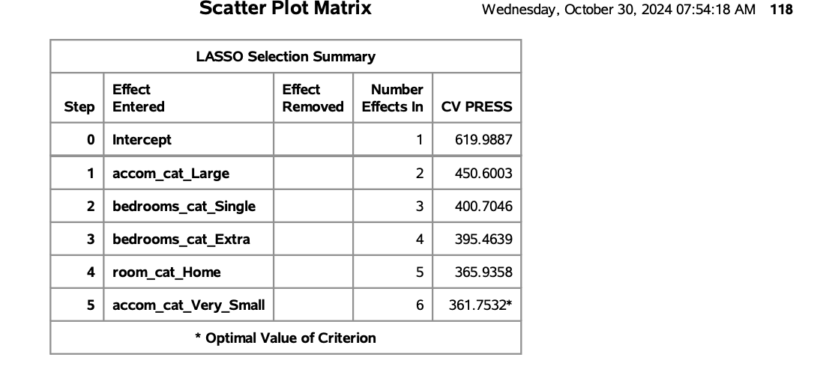

- Model Optimization: At each step, LASSO added a new predictor, reducing the CV PRESS significantly, with an optimal value achieved at 361.7532 in Step 5.

- Influential Predictors: Notable predictors retained include accom_cat_Large, bedrooms_cat_Single, bedrooms_cat_Extra, room_cat_Home, and accom_cat_Very_Small. These variables substantially impact listing prices.

- Exclusion of Variables: Interestingly, variables like max_nights_tf and rating_cat were not included, indicating minimal influence on listing prices. This suggests that hosts do not necessarily price listings higher for extended booking durations or consistently positive ratings.

The summary demonstrates a targeted approach by LASSO, focusing on predictors that improve model accuracy, providing deeper insight into factors influencing Airbnb pricing strategies.

This plot illustrates the progression of coefficients and cross-validated prediction error (CV PRESS) as the LASSO model selects variables step-by-step for predicting Price_Log.

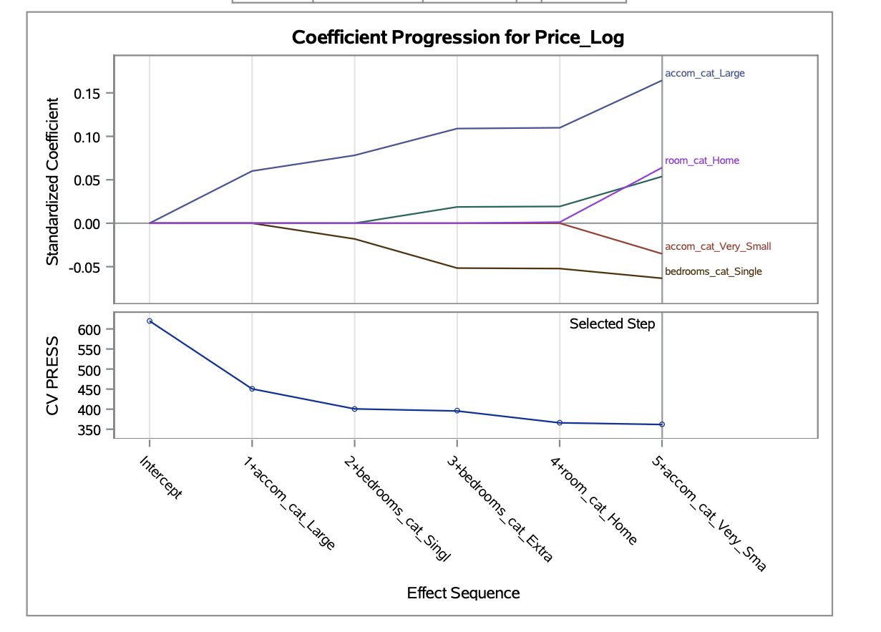

- Top Plot (Coefficient Progression): This visual shows how the standardized coefficients of selected variables change with each step in the LASSO process. Key variables like accom_cat_Large and room_cat_Home show an increasing positive effect on the response variable, indicating that larger accommodation categories and entire homes positively impact price. Conversely, accom_cat_Very_Small and bedrooms_cat_Single display a decreasing trend, suggesting a negative impact on price.

- Bottom Plot (CV PRESS): This plot shows a steady decrease in CV PRESS with each step, reaching the lowest value at Step 5. This indicates that the model achieves optimal predictive accuracy with the inclusion of six variables, balancing complexity and prediction error.

Finally, the selected features capture important distinctions in property characteristics that contribute to the price, with LASSO helping to refine the model to include only the most predictive features.

This box plot visualizes the distribution of residuals for the dependent variable Price_Log.

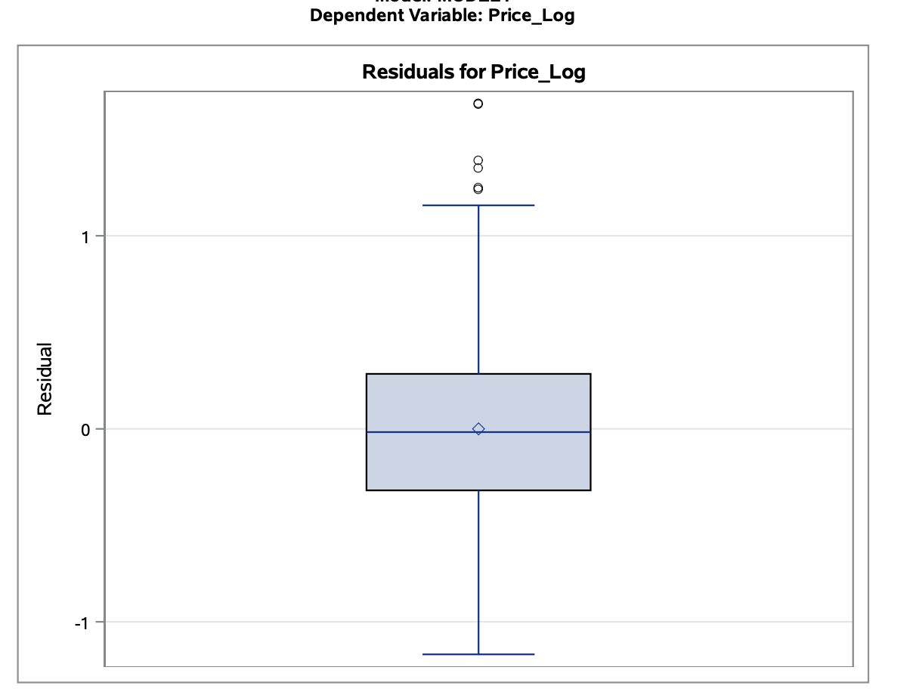

The median residual is centered around zero, indicating that the model predictions are generally accurate with minimal bias. The interquartile range is relatively compact, with most residuals falling between -0.5 and 0.5, suggesting that most of the predictions are close to the observed values. A few outliers are present above 1, indicating some deviation in specific cases, but these do not appear to significantly impact the overall model performance. This residual spread supports the robustness of the model.

This comprehensive diagnostic plot set provides insights into the model's performance and assumptions:

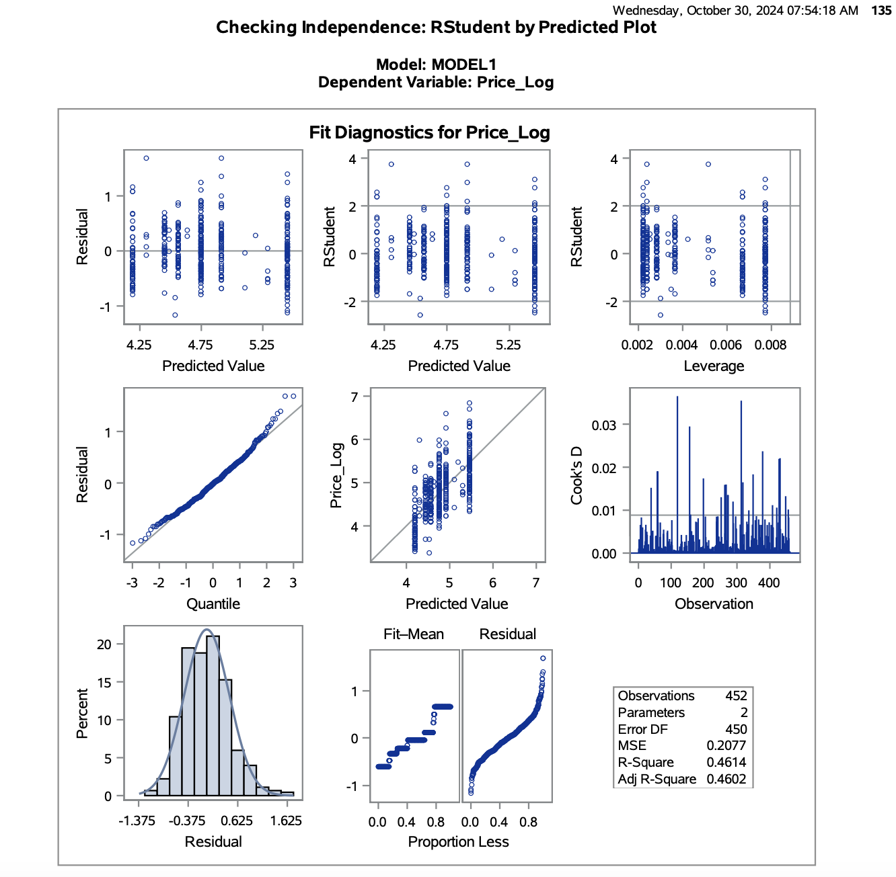

1. Residual vs. Predicted: Residuals are randomly dispersed around zero, indicating good model fit and no significant heteroscedasticity.

2. R Student Plots: Standardized residuals show no extreme outliers, supporting assumption validity.

3. Leverage and Cook’s D: Most data points have low leverage and Cook's D values, indicating minimal influence of individual points on the model.

4. Quantile Plot: Residuals follow a near-linear pattern, indicating normality.

5. Histogram of Residuals: Residuals display a bell-shaped distribution, further supporting normality.

6. Predicted vs. Observed: Predicted values align closely with observed values, showcasing model accuracy.

The diagnostics confirm that the model assumptions are reasonably met, supporting reliable predictions.

**Decision Tree**

The decision tree analysis reveals key predictors impacting the target variable. Starting from the root (Node 0), the model first splits on accom_cat, indicating that accommodation size significantly affects price.

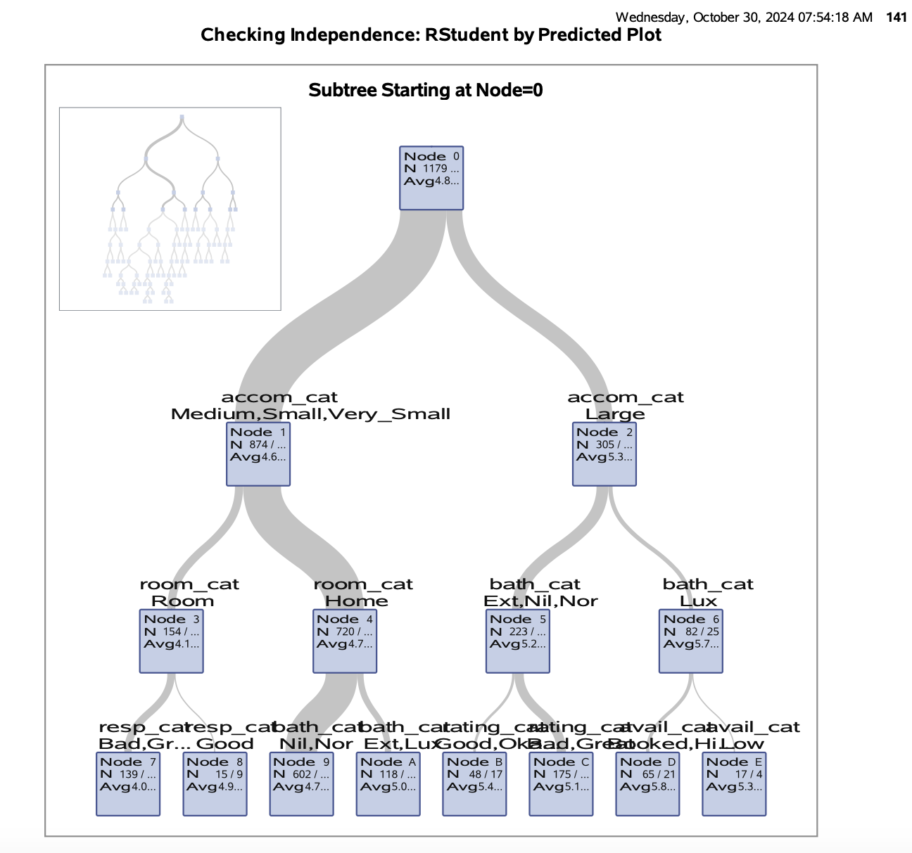

Listings with accom_cat as "Large" (Node 2) generally have higher prices, while smaller categories (Node 1) further split by room_cat and bath_cat, highlighting the impact of room type and bathroom features.

This structured branching underscores the influence of listing size, type, and amenities on pricing, with average values at each node providing insights into incremental pricing tiers. This visual model succinctly categorizes listings for targeted pricing strategies.

From the decision tree, we can derive the following insights:

- Accommodation Size: Larger accommodations (accom_cat = Large) generally command higher prices.

- Room Type: For smaller to medium accommodations (accom_cat = Medium, Small, very_Small), the type of room (room_cat) further influences price.

- Bathroom Category: In cases where the room type is "Home," the bathroom category (bath_cat = Ext, Nil, Nor) significantly affects pricing, with "Lux" bathrooms fetching the highest average prices.

- Availability Impact: In specific splits, higher availability (like "Low" in avail_cat) can slightly reduce the price, suggesting demand-sensitive pricing.

These factors indicate that room size, room type, and luxury amenities (bathrooms) are primary drivers of pricing in the model.

This table provides a summary of variable importance across training and validation datasets. The Relative Importance score highlights the impact of each variable in predicting the target outcome, with higher values indicating stronger influence.

Key points:

- accom_cat (Accommodation Category) is the most influential predictor, consistently ranking highest in both training and validation sets.

- room_cat and resp_cat also show substantial predictive power, with notable importance values.

- Variables like min_nights_tf and bath_cat have moderate influence, while others like rating_cat and acc_cat contribute minimally or not at all in validation, indicating less relevance in predicting price.

This analysis guides model refinement by highlighting which predictors to prioritize for improving predictive accuracy.

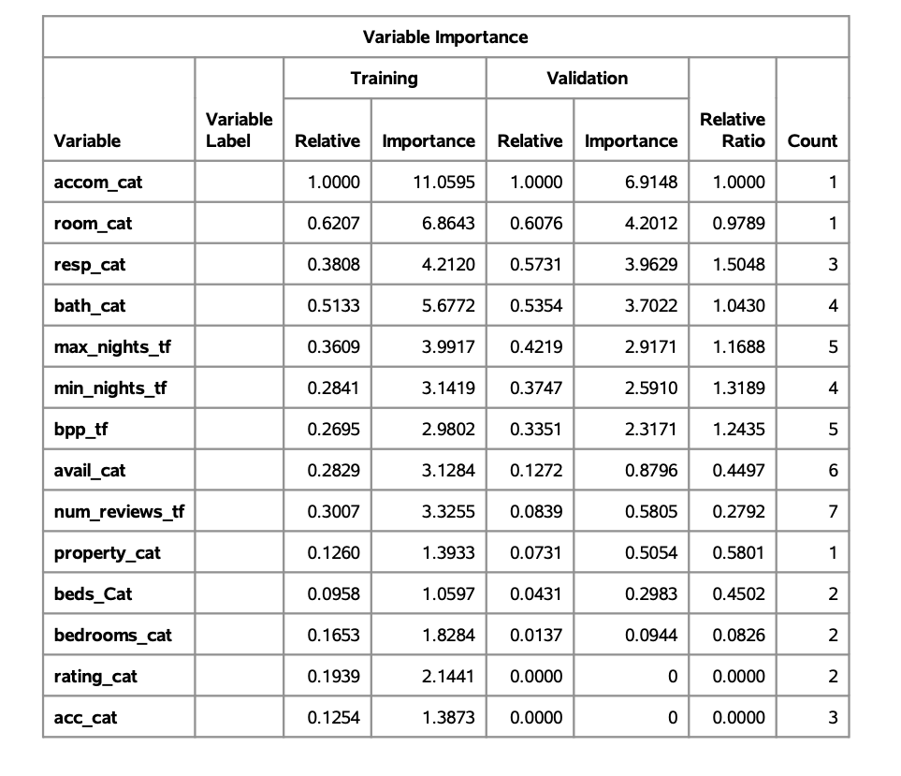

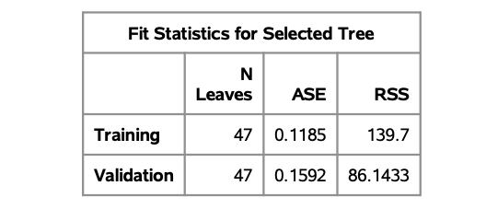

This table provides fit statistics for the selected decision tree model. It shows that the tree has 47 leaves, with an ASE (Average Squared Error) of 0.1185 on the training set and 0.1592 on the validation set. The RSS (Residual Sum of Squares) values, 139.7 for training and 86.1433 for validation, indicate the overall error. These metrics help evaluate the model's accuracy and its performance on unseen data.

This table shows the importance of variables in terms of loss reduction for model prediction.

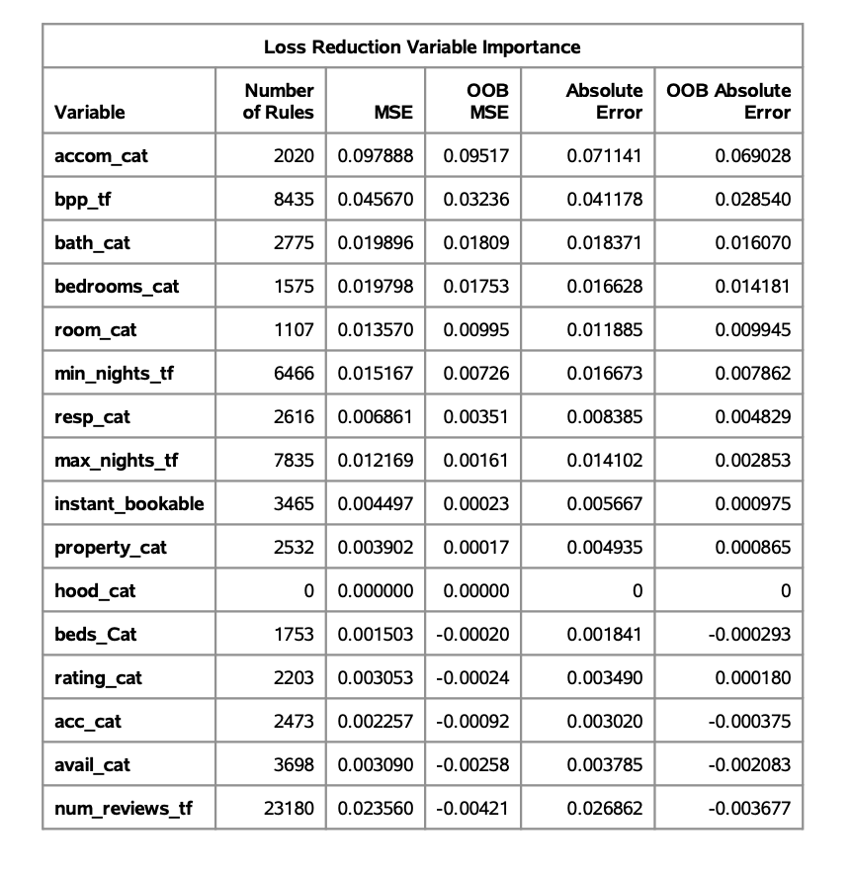

Each variable’s impact is assessed using metrics like MSE (Mean Squared Error) and Absolute Error, both in-sample and Out-of-Bag (OOB).

Key variables like accom_cat and bpp_tf contribute the most to reducing error, with higher MSE and Absolute Error values. Variables with minimal or negative OOB values, such as beds_Cat and avail_cat, have lesser predictive importance in the model. This helps prioritize impactful variables for model efficiency.

**Conclusion:**

This analysis aimed to build a robust predictive model for Airbnb listing prices in Columbus, Ohio, using exploratory data analysis, outlier handling, and feature optimization to enhance prediction accuracy.

1. Model Comparison: Among linear regression, decision tree, and random forest models, the linear regression model proved to be the most reliable and balanced choice. It exhibited the lowest generalization error on test data, unlike more complex models, which showed signs of overfitting.

2. Key Insights:

- Primary Drivers of Price: High-demand neighborhoods, entire home listings, greater guest capacity, and additional bedrooms and bathrooms emerged as key factors positively influencing price. In contrast, variables like ‘maximum nights’ and ‘host ratings’ had minimal impact, indicating that Columbus hosts may not prioritize these factors in pricing.

- Value-Added Features: Listings with extra amenities, particularly additional bathrooms and higher guest capacities, were linked to higher prices, highlighting their perceived value to guests.

3. Recommendation: The linear regression model is recommended for its reliability in predicting listing prices and its clarity in interpretation, making it a valuable tool for stakeholders. This model offers a data-backed perspective on pricing dynamics, enabling Airbnb hosts and market analysts to anticipate price trends in the Columbus area effectively.

This refined model provides both predictive strength and actionable insights into factors that matter most in the Columbus Airbnb market.

Outliers:  
  
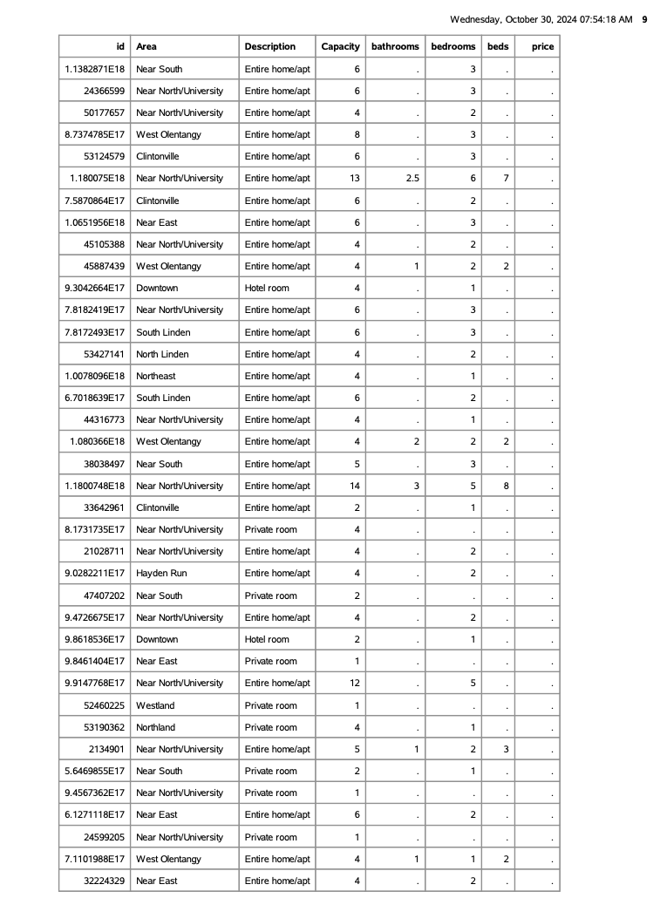

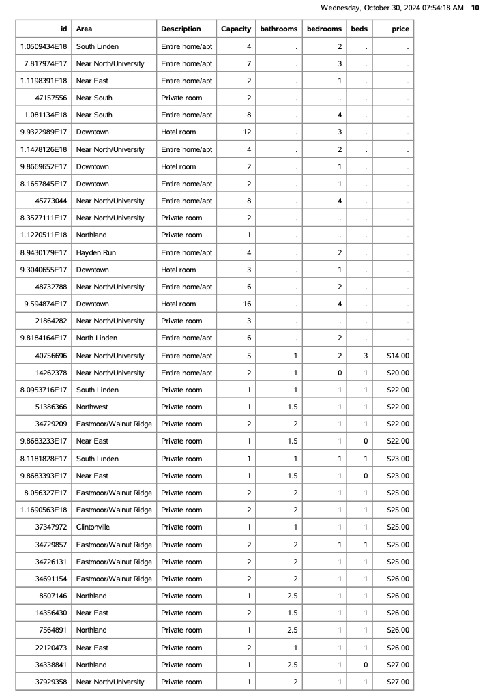

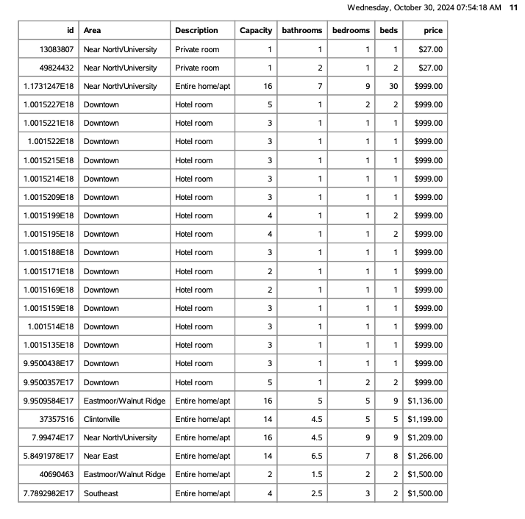

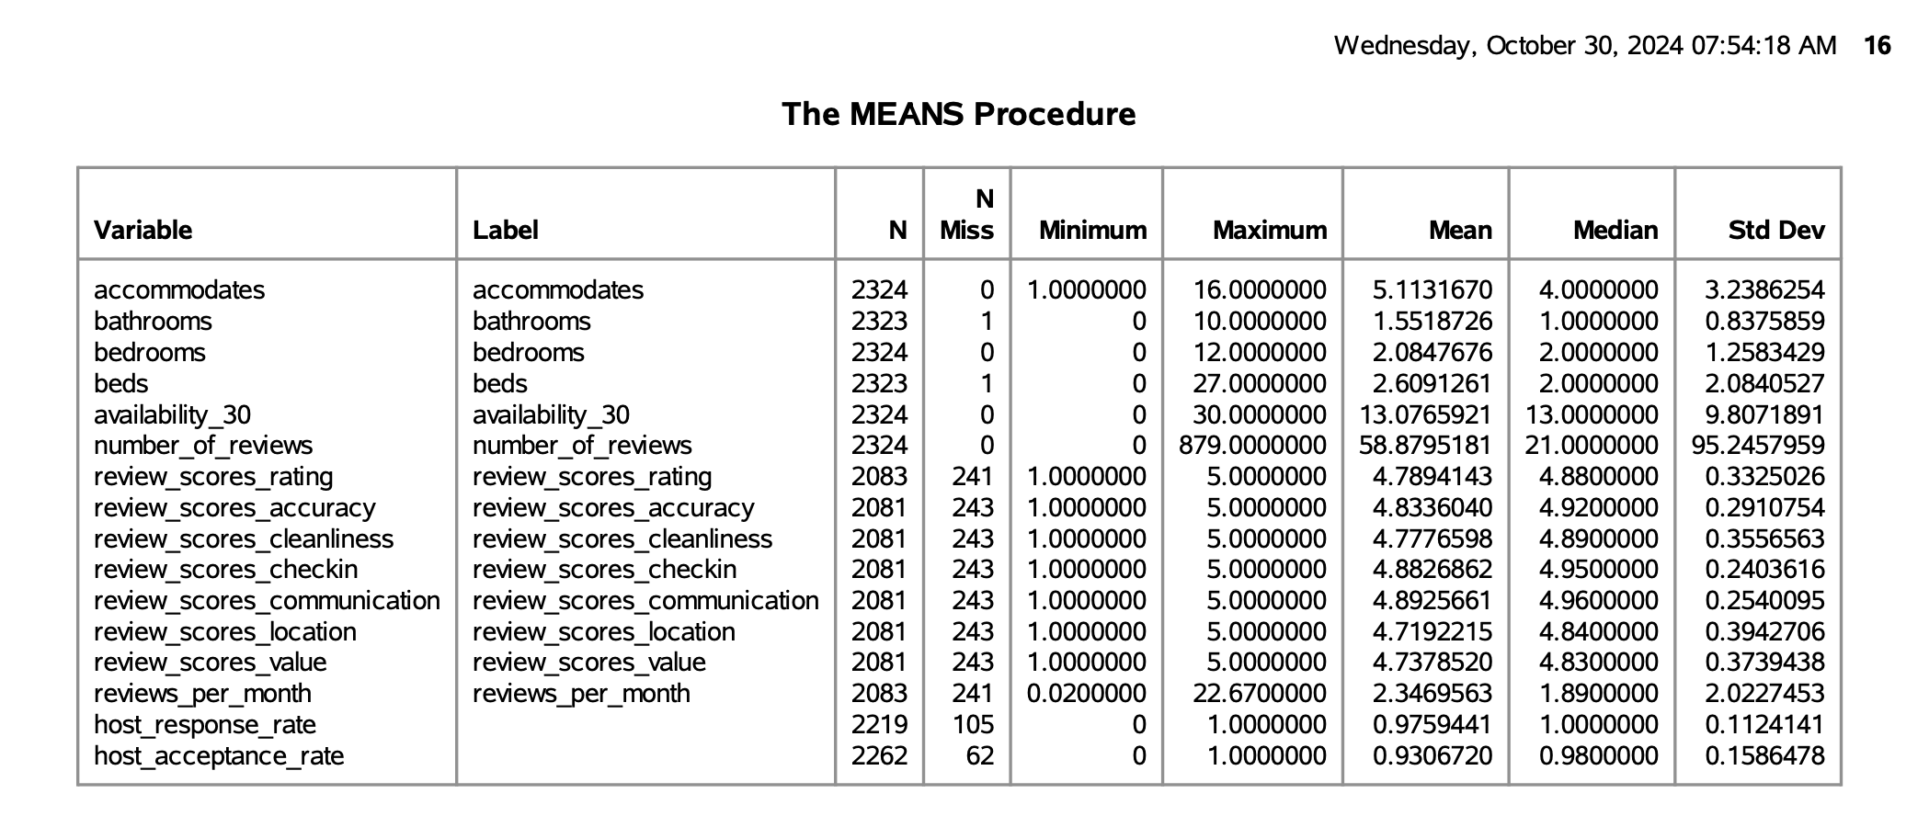

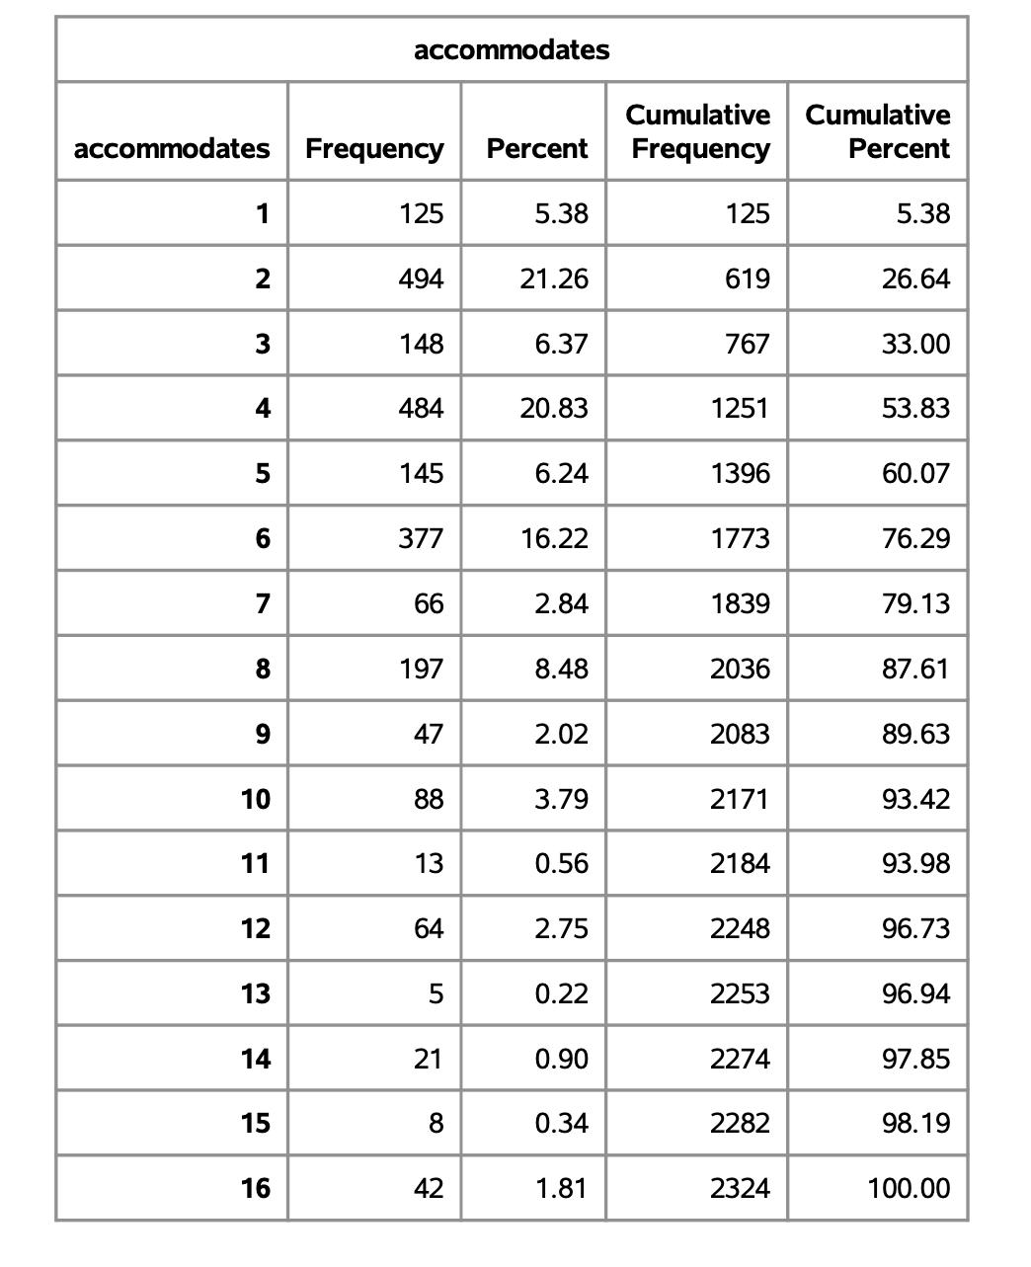

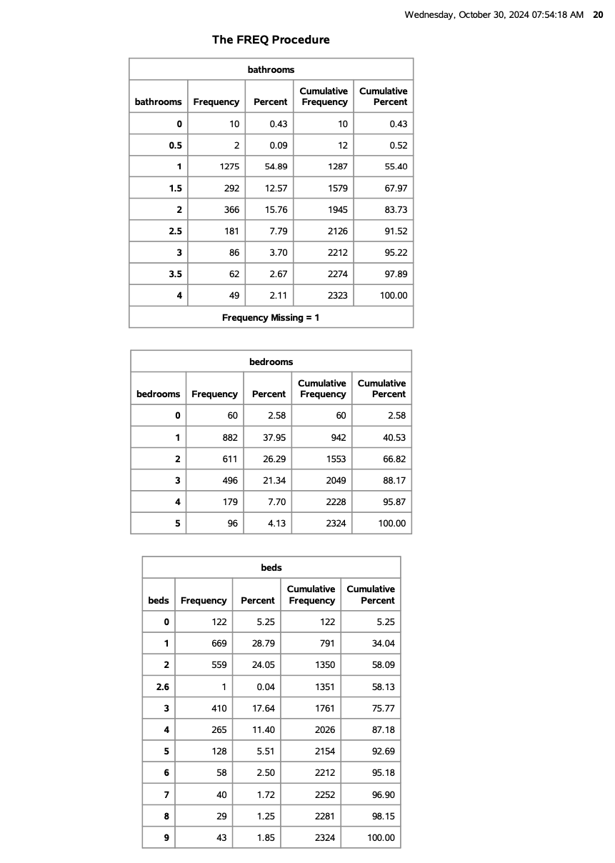

Scatterplot Matrix : Non-normal Predictors